**Acting Principal: Andrew King**

Redesdale Mia Mia PS

Phone: 5425 3155

Email: [redesdale.mia.mia.ps.ps@edumail.vic.gov.au](mailto:redesdale.mia.mia.ps.ps@edumail.vic.gov.au)

**Vision:**The community of Redesdale-Mia Mia Primary School considers itself a family that fosters well-being and embraces diversity. We strive to develop independent leaders who are globally capable.

**Own a dingo and need some work?**

We have numerous piles of wood chips around the school that need to be spread out in different areas. If you are keen to get some paid work, please contact Redesdale Mia Mia Primary School on 5425-3155.

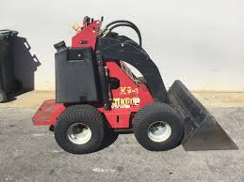

***Principal Introduction***

I would like to introduce myself as the new Acting Principal of Redesdale Mia Mia Primary School. My name is Andrew King and I have been working at Camp Hill Primary School in Bendigo for the past four years. Prior to that, I was working in Shepparton and Mooroopna.

I have two young daughters and my wife has worked at Redesdale Mia Mia Primary School as a Casual Relief Teacher for the past two years. I thoroughly enjoy the outdoors, gardening and most sports (go the Pies).

Although we are not able to meet in person with families, I am very excited to step into this position and work with the wider community. I am looking forward, as we all probably are, to opening our doors and meeting everyone person to person.

A: Dozens

**Remote Learning**

As you are all aware, students are being asked to work remotely sue to Covid-19. This has posed significant demands on families. I would like to acknowledge and recognise the impact that this has on working families. As a father of a Grade One student, I can say that we also are feeling the impact of this at our house. Please make sure that you are taking care one another during this chaotic time.